**Radio Control Panel (RCP)**

# Geoff Anderson G3NPA, Jim Hargrave W5IFP, Javier Bermejo EA1AUS (SK) and Aki Yoshida JA1NLX

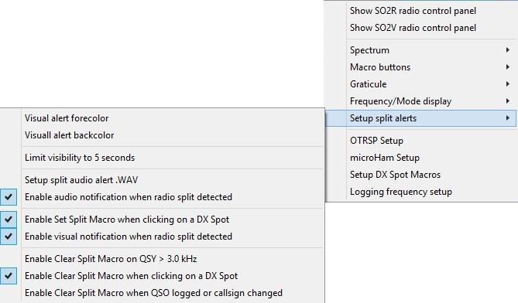

RCP_6A

### 2.7 Logging frequency setup

This option provides the user with several logging options when operating in Split mode.

Option “Automatically calculate FREQ frm FREQ_RX” corrects the SDR-Console FREQ and FREQ_RX frequencies and changes the Band from 3CM to 13CM (the TX band)

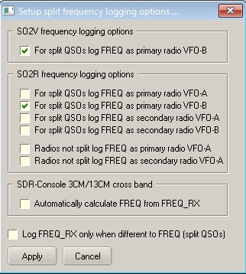

new RCP_6B

## 3.0 MACRO BUTTONS

Setting up these buttons is exactly the same as is described in the Programmable Buttons topic.

**Note** however that the list of Macros designed for use in the CW Machine and the Sound Card Data wiindow do not apply here except for those detailed below. The primary use of these buttons is for the control or parameter changing of the actual radio in use so the basic Macros of $command$ and $hexcommand$ are the main ones to use here.

There is a set of Macro buttons for each of the definable radios. This allows for the single radio user to employ up to 72 macro buttons by setting Radio 2 CAT parameters to the same as Radio 1 and using the <**Ctrl+T**> key combination to swap radios, providing a second set of 36 buttons.